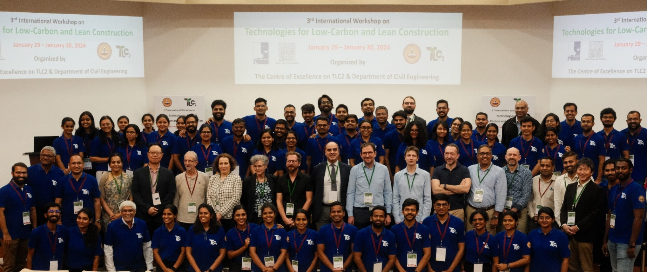
The TLC2 team with invited speakers at Indian Institute of Technology Madras during TLC2 Workshop 2024 (January 28-31) organized in association with RILEM Association. Image courtesy of the Centre of Excellence on TLC2.

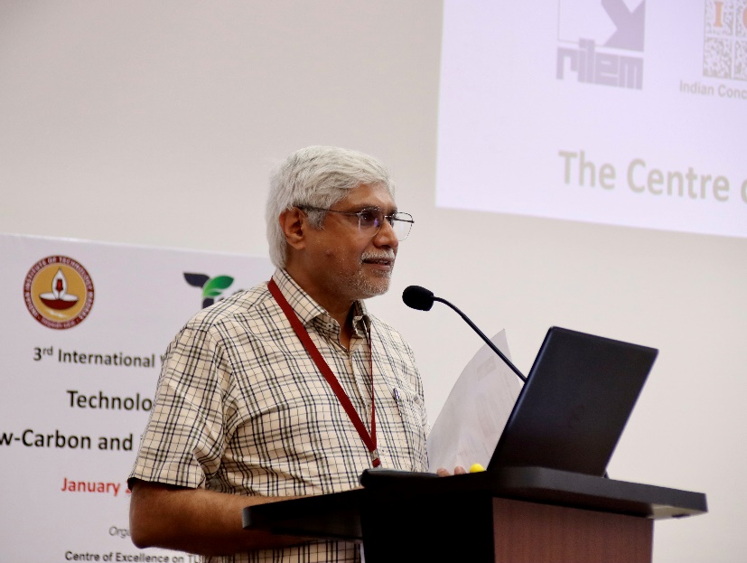
The 3rd International Workshop on Technologies for Low-Carbon and Lean Construction (TLC2) was organized by the Centre of Excellence on TLC2 in association with RILEM Association from January 28th-31st, 2024, at the Indian Institute of Technology Madras. The TLC2 Week witnessed the enthusiastic participation of more than 200 participants from Industry, Academia, Government organizations and the student community. The event aimed to disseminate the recent findings and identify new challenges in the areas of TLC2 through interactions with relevant national and international stakeholders working in these areas.
Welcome address by Prof. Ravindra Gettu. Image courtesy of the Centre of Excellence on TLC2.
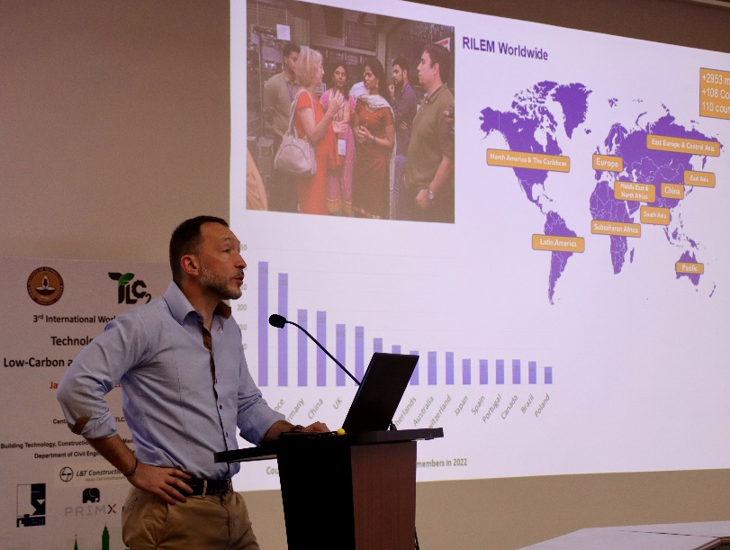
The week-long programme included the following:
💡DAY 1: Young Researchers’ Symposium (YRS)
💡DAY 2 & 3: Two-Day TLC2 Workshop
💡DAY 4: One-Day Workshop on Realizing Sustainability-Role of Contract and Law in Indian Construction

Young Researchers’ Symposium (YRS)

The Young Researchers' Symposium (YRS) on TLC2, is a premium forum for promoting and supporting young researchers working on TLC2 areas. After rigorous scrutiny of applications received after a global call, 14 young researchers, mainly senior Ph.D. scholars and recent PhD graduates, were invited to present their work. The Best YRS Speaker received the SURENDRA P. SHAH AWARD on Technologies for Low-Carbon and Lean Construction (TLC2) – 2024. The YRS event started with a welcome address by Prof. Ravindra Gettu. Prof. Mark Alexander, former RILEM President (2013-2015) headed the jury. Prof. Nicolas Roussel delivered a talk on “About RILEM”.
Dr Nicolas Roussel, RILEM President, presenting RILEM. Image courtesy of the Centre of Excellence on TLC2.
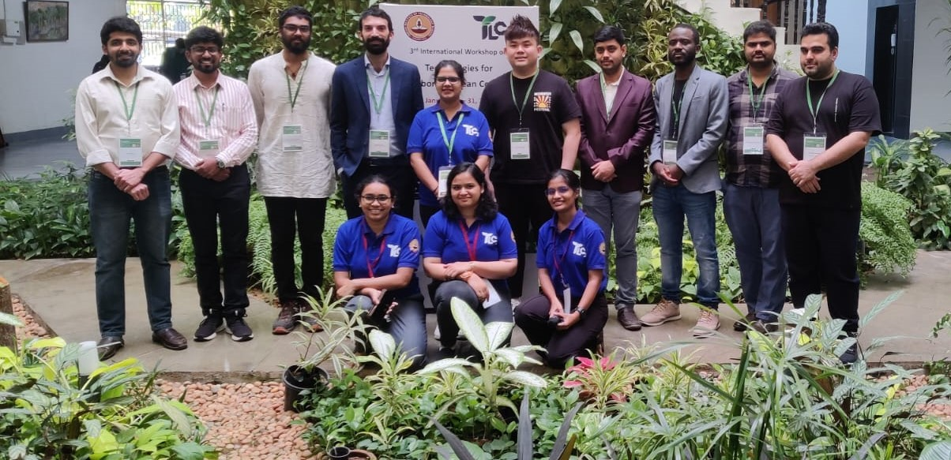
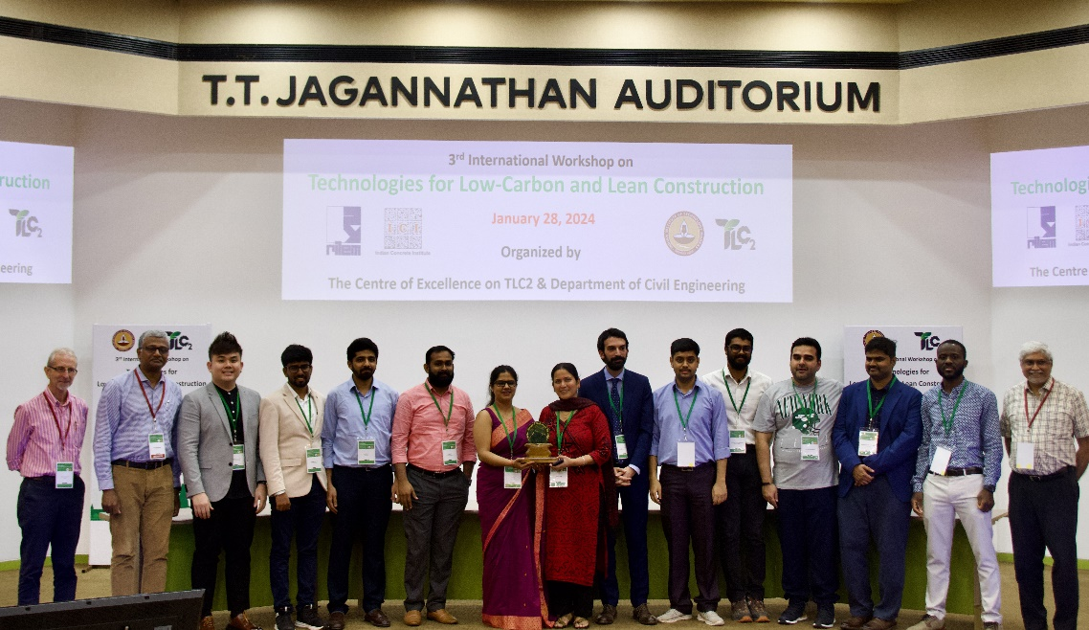
Dr. Purnima Dogra, a recent PhD graduate from Thapar Institute of Engineering and Technology, India was adjudged as the best young researcher for his research and recommended by the Jury for the Surendra P Shah Award 2024. She presented her research on “Inhibition Mechanism of Amino Acids against Carbonation-Induced Corrosion in Reinforced Concrete”. The YRS event included a poster presentation session for MS & PhD students working in TLC2 areas. The Best Poster Award went to Ashutosh Dwivedi, a PhD student from Indian Institute of Science (IISc). Young Researchers' Symposium travel grants was awarded to the following PhD researchers:
Prof. Mark Alexander (first from the left), Prof. Ravindra Gettu (first from the right) and Prof. Manu Santhanam (second from the left) with the participants of the YRS . Image courtesy of the Centre of Excellence on TLC2 . Purnima Dogra and other YRS 2024 finalists
- Ervin Tiu Shan Khai from Monash University Malaysia
- Moro Sabtiwu from University of Leeds, UK.
All YRS finalists with YRS organizers at IIT Madras. Image courtesy of the Centre of Excellence on TLC2.
- Ali Rakhsh Mahpour from UPC, Universitat Politècnica de Catalunya, Spain.

Two-Day TLC2 Workshop

The TLC2 workshop was inaugurated by Prof. Manu Santhanam, Dean IC & SR, IIT Madras. Prof. Benny Raphael, Head of the Department of Civil Engineering welcomed the participants and Prof. Ashwin Mahalingam, Director of School of Sustainability, IIT Madras, spoke about new initiatives on sustainability.
During the workshop, six sessions were held. In each session, the discussion leader set the stage with an introductory talk on the theme of the session followed by presentations by invited speakers.

The speakers and their topics are shown in the table below::

Session 1 – Computational Materials Modelling of Cementitious Systems
Discussion Leader: Aslam Kunhi Mohamed (IIT Madras)
Guoqing Geng (NUS, Singapore) | The Nano-scale Mechanical interaction between C-S-H Particles
N. M. Anoop Krishnan (IIT Delhi, India) | Artificial Intelligence for Sustainable Cement Production
Saptarshi Sasmal (CSIR-SERC, India) | Nano-scale modelling, investigations and engineering to develop multi-functional cementitious composite
Session 2 – Rheology and 3D Printing of Concrete
Discussion Leader: Manu Santhanam (IIT Madras)
Nicolas Roussel (Gustave Eiffel University, France) | Life Cycle assessment of extrusion-based 3D printing technologies
Richard Buswell (Loughborough University, UK) | Hybrid manufacturing: Going beyond 3D Concrete Printing
Kolluru V.L. Subramaniam (IIT Hyderabad, India) | Challenges in Rheological Measurement and Printing with Alkali Activated Binders
Session 3 – Technologies for Built Environment Sustainability
Discussion Leader: Ashwin Mahalingam (IIT Madras)
Albert Thomas (IIT Bombay, India) | Sustainability in Numbers: Importance and Challenges of Quantification
Monto Mani (IISC Bangalore, India) | Sustainability in the built environment: emerging concerns
Mili Majumder (Green Building Certification Institute India), and US Green Building Council, USA) | Linkages between design and performance monitoring of Indoor environmental quality in green buildings

Session 4 – Low Carbon Construction Materials
Discussion Leader: Karen Scrivener (EPFL, Switzerland)
Thomas Matschei (RWTH Aachen Univ., Germany) | Thermodynamic modeling - key for sustainable cement design?
Emmanuel Gallucci (Sika Technology AG, Switzerland) | Tailored cement activation based on advanced understanding of basic mechanism/chemical interactions
Taehwan Kim (Univ. of New South Wales, Australia) | Effect of MgO on the reactivity of GBFS in sodium silicate activated systems
Luis Edgar Menchaca Ballinas (IIT Madras) | In situ caustification activation of SiO₂-rich precursors
Session 5 – Durability and Sustainability
Discussion Leader: Mark Alexander (University of Cape Town, South Africa)
Kei-ichi Imamoto (Tokyo University of Science, Japan) | Carbonation and its relation to re-bar corrosion of concrete building using ground granulated blast furnace slag over 60% under real condition for about 60 years
Elena Redaelli (Politecnico di Milano, Italy) | Electrochemical methods for the protection and repair of reinforced concrete suffering corrosion
Yuvaraj Dhandapani (University of Leeds, UK) | Advances in characterising carbonation in low clinker and alternative cements
Sudharshan N. Raman (Monash University Malaysia) | Ultra-High-Performance Concrete (UHPC):  Transitioning Towards Sustainability and Lean Construction
Session 6 – Life Cycle Analysis / Industrial Ecology
Discussion Leader: Ravindra Gettu (IIT Madras)
Liberato Ferrara (Politecnico di Milano, Italy) | Advanced construction processes implementing advanced materials to enhance the sustainability signature of the built environment
Anusha S. Basavaraj (Imperial College London, UK) | Transition Towards Low Carbon Concrete - Persuading Parameters
Michał P. Drewniok (University of Leeds, UK) | The necessary embodied carbon cost to deliver future needs.

Centre of Excellence on TLC2 wholeheartedly thank the sponsors PrimeKss Group Latvia and L&T – Heavy Civil Infra IC for sending delegates and supporting the TLC2 Workshop 2024. Mr. Ivo Erglis – Kupins from Primekss delivered a talk on “GHG emission reduction in construction by utilising self-stressing steel-fibre reinforced concrete (SSSFRC) technology”.
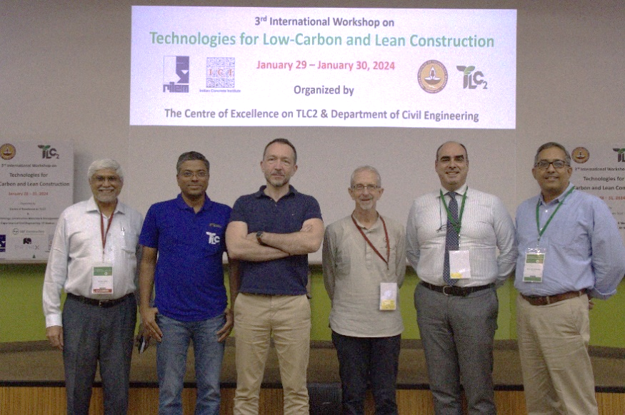

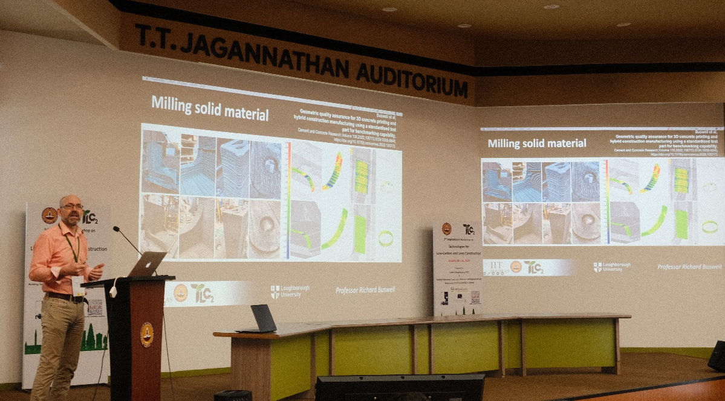
From left: Prof. Ravindra Gettu, Prof. Radhakrishna G. Pillai, Dr Nicolas Roussel, Prof. Liberato Ferrara and Prof. KVL Subramaniam. Image courtesy of the Centre of Excellence on TLC2.

Prof. Richard Buswell speaking on Hybrid manufacturing: Going beyond 3D Concrete. Image courtesy of the Centre of Excellence on TLC2.Printing
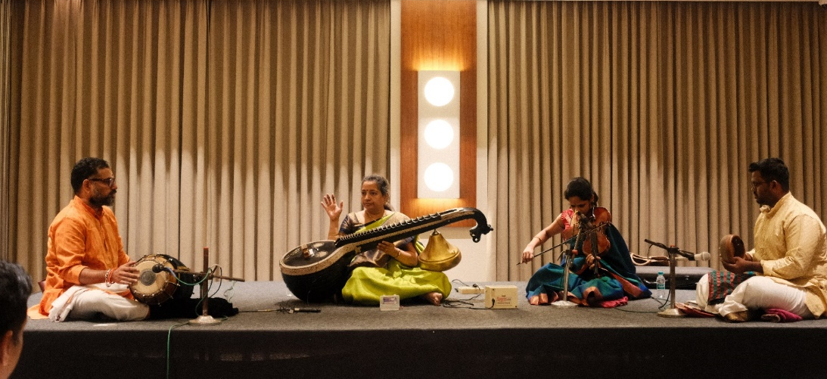

Cultural program during the Banquet Dinner. Image courtesy of the Centre of Excellence on TLC2.

