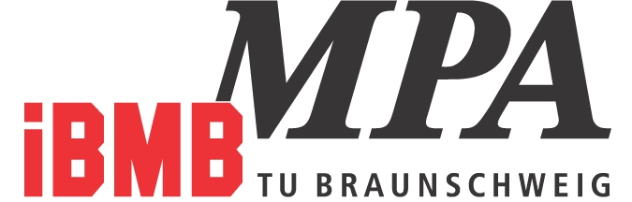


The Department of Organic and Wood-Based Construction Materials
of the Institute for Building Materials, Heavy Construction and Fire Protection, TU Braunschweig, Germany

is looking for a
Research Assistant
- with focus on dynamics of structures -
Full time employment with initial contract for two years
(with the option of an extension)

Our profile:
The Institute for Building Materials, Heavy Construction and Fire Protection (iBMB) belongs to the School of Architecture, Civil Engineering and Environmental Sciences. It is a joint institute of four different departments: building materials and reinforced concrete construction, organic and wood-based materials, heavy construction as well as fire protection and foundations of heavy construction.
The Department of Organic and Wood-Based Construction Materials was founded in 2010 in order to address urgent issues of renewable resources and their efficient use in the field of civil engineering and to develop a relevant research program. A connection between the department and the Fraunhofer Wilhelm Klauditz Institute in Braunschweig offers excellent opportunities for synergies between basic and applied research. The TU Braunschweig is one of the leading teaching and research institutions of higher education in Germany and Europe with excellent research. Braunschweig is a dynamic city that offers number of cultural and recreational opportunities.
Your tasks:
- Your main activity will focus on increasing your competence in the field of structural dynamics. You are expected to develop new research ideas, write research proposals and perform relevant research.
Your profile:
- PhD degree in civil or mechanical engineering (or equivalent) with excellent knowledge of engineering mechanics, dynamics, vibration theory, proficiency in numerical modelling and/or experimental mechanics
- PhD degree is desired, however, highly qualified applicants who do not hold a doctorate will also be considered.
- Team-player, creativity and the ability to work independently while focusing on results
- Excellent writing skills
- Excellent knowledge of German or English (or both) is required

This full-time position is to be filled immediately, initially for a two years period (with the option for an extension). The employment contract is based on the wage scale of the German public service TV-L (E13). The TU Braunschweig strives to increase the number of women and hence strongly encourages the application of female scientists. Disabled persons with adequate qualification will be preferentially considered. Applications are accepted until the position is filled.

Further information:  For further information on this position please contact:  Dr.-Ing. J. Hinrichsen  phone: +49 531 22 077 - 0  URL of the Institute:  http://www.ibmb.tu-braunschweig.de |  | Please send your application to:  Institut für Baustoffe, Massivbau und Brandschutz  Fachgebiet Organische Baustoffe und Holzwerkstoffe  Prof. Dr.-Ing. Bohumil Kasal  Hopfengarten 20  38108 Braunschweig  Germany  or via email (preffered):  bo.kasal@tu-braunschweig.de

